As part of the research evaluation team, we were tasked with conducting a quantitative analysis of the UPMC Hillman Academy. An immersive mentored research program focused on providing an intensive STEM research experience to a diverse group of high school students. The evaluation focuses on investigating whether the outreach program increased student postsecondary participation and persistence, particularly in STEM-related fields, with a particular focus on the outcomes for historically underrepresented students.

Analytic Approach

Ideally, we would assess the impact of this intervention in the context of a randomized controlled trial in which we first identified students eligible for outreach and then, among those eligible for outreach, we randomize students to a treatment condition in which they receive the research experience or a control condition in which they do not. Such a design is not possible in this scenario, given practical barriers. Therefore, we will take a non-experimental approach to assess impacts. To do so, we propose to employ a combination of two different analytic strategies: matching and differences-in-differences.

Those students who applied and were accepted to the Hillman Academy are considered our “intervention students.” We propose to match intervention students to observationally similar students to students who applied to the Hillman Academy but were not accepted; we refer to this group as “applicant students”. The difference in outcomes between the intervention students and applicant students who were not selected for the intervention constitutes our first difference. Due to selection bias, it is expected that students who applied but were not accepted likely have a similar postsecondary outcomes to those who participated in the Hillman Academy. Therefore, to strengthen our causal claim, we look for demographically similar students who never applied to the Hillman academy using individual student data using IES-restricted datasets. Specifically, we match intervention and applicant students to demographically similar students in the IES data. We then take the difference in outcomes between the IES-matched applicating student and participant student, this constitutes our second difference. This second difference is used to adjust our first difference by removing some, but not all, of the variation in outcome due to selection bias.

Work Update

To date, data cleaning is complete, including outcome data gathered through the National Student Clearinghouse. Significant progress has been made in the first-difference analysis. Using propensity score matching, we matched intervention students to demographically similar applicants. Our matching approach was successful, and we achieved a balance of student characteristics available to us. Figures 1 & 2 show the propensity core distribution before and after matching. Preliminary findings confirms our inclination that we see a non-significant difference in our postsecondary outcomes between those who participated in the program and those who did not participate in the program. This is likely driven by the relatively high-achieving sample of applicants and participants. Therefore, the second difference will inform a critical portion of our analysis.

We applied for a restrictive data license through IES to gain access to our second difference data. We recently received confirmation that our application was approved. The remaining work will focus on generating the second difference matches and employing our full difference-in-difference framework. We will develop an internal research memo for the Hillman stakeholders. We also plan to submit an academic manuscript of our finding to a higher education or STEM-related journal.

Figure 1. Propensity score distribution between treated and untreated students

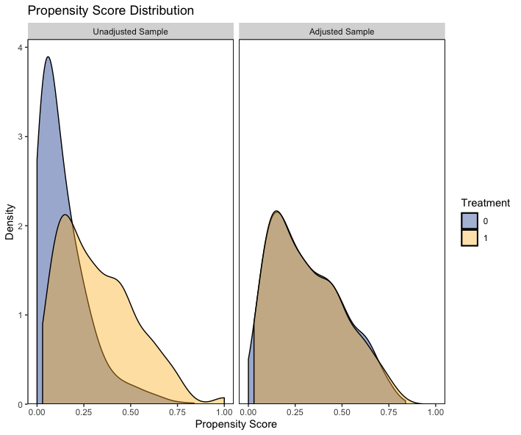

Figure 2. Propensity score assessment between treated and untreated students

